**ABSTRACT**

In today’s world we have seen different kinds of technologies on the rise. Facial Recognition too is one of those technologies that has seen considerable amount of rise in the times. Its use in Information Security, Biometrics, Law enforcement and surveillance systems make it that much more important. In real time it is one the challenging, interesting and fast-growing area. In last decade there have been many efforts put to bring facial recognition into existence for its application like in security surveillance systems or for the enforcement of law using development of different algorithms. Also, how Facial Recognition can be used for various more purposes is covered along with advantages and limitations of this technology and also how to overcome these limitations. In this report it is shown how the LBPH algorithm is used to execute facial recognition.

**1.INTRODUCTION**

**1.1 WHAT IS FACIAL RECOGNITION?**

A Face Recognition is a Biometric solution designed to recognize human face without any direct contact. A facial recognition system uses algorithms that match the images stored in the database to the facial nodes of a person. This usually works by extracting the unique features of the face and then comparing with the images we have in the database to find a match.

Facial Recognition generally detects a face from a photo like in Facebook or various other social media sites where it automatically detects a face and tags it when a face appears in a post.

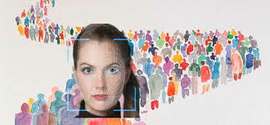

***Fig. 1: Facial Recognition technology is capable of identifying a person in the crowd (source: Google)***

**1.2 FACE DETECTION vs FACE RECOGNITION**

Now that we know what Facial Recognition is, we need to understand that it is quite different than Face detection.

* Face Detection technology is a technology that can just confirm if the image it is processing has a human face or not it won’t identify who that person is, while Face Recognition technology is efficient in identifying a person by face.

Face Detection technology is included in Face Recognition technology it’s not the other way around. Face Detection technology is basically the first step in facial recognition or identification a person using Facial Recognition Technology. Hence before we jump into what algorithm options are available for Facial Recognition we shall go over the algorithm we use for the face detection.

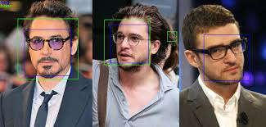

***Fig. 2: Only the face of humans can be detected by Face Detection technology (source: Google)***

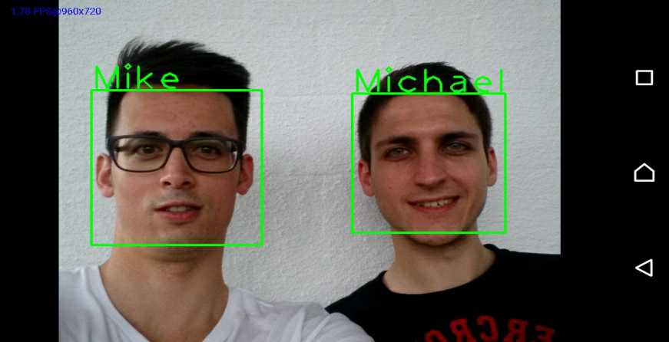

***Fig. 3: Facial Recognition Technology can identify a person’s face with their proper identity(source: Google)***

**1.2.1. Haar-cascade classifier:** This is a method, invented by Viola and Jones which trains a machine learning for detecting objects in a picture. In this context, it can be used to detect faces. A weak classifier is a classifier which is somewhat superior to the random predictions. This feature is a rectangle which is parts into two or more rectangles. Every rectangle shape is black or white. Figure 4 shows the various potential features. With the assistance of various positive and negative photos the training of Haar-cascade is accomplished.. In this the object to be perceived are in the positive pictures though the pictures without objects are in the negative picture. In this context, a positive picture possesses a face, and a negative picture does not. This machine learning requires grayscale pictures. By using the intensities of gray we detect which feature it is representing. And by subtracting the sum of dark pixels by the sum of bright pixels present in the area, the features are found. The extraction of features from training part will be utilized for finding face in photos.

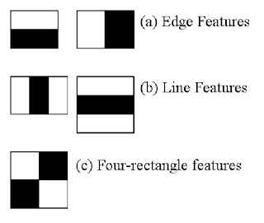

***Fig. 4: Haar Cascade Features(source: Google)***

**1.3 HOW DOES THE FACIAL RECOGNITION TECHNOLOGY WORK?**

So, now that we understand what Facial Recognition means and how is it different from Face Detection, we might be wondering how does it work and what is its process and how is Face Detection technology is a part of Face Recognition process?

Leaving behind the different techniques, there are mainly 3 steps involved in Facial Recognition process, they are:

* Detecting a face
* Training the model of facial recognition
* Recognition of face

1. Detection of a face: This is the part where Face Detection technology comes under play as we have discussed it is the first step for facial recognition method. The computer locates the human face by the determination of size and location in digital images. The photo as perceived by the algorithm used for Facial Recognition has a definite set of colour value to each pixel, it checks for different brighter or darker parts of image or the contrast difference in the image. The difference of data between the pixel values in grayscale by scanning repeatedly is done and thus the face is detected by the machine. In this the computer basically detects a face in the form of an input image which is taken by the camera and that image is captured in the form of a grayscale image.
2. Training the model: After the image has been captured and preliminary processing of data has been completed then comes the performing of dataset training. For the purpose of recognizing, training the dataset is important. In training various algorithms for facial recognition can be applied. In our project we used the LBPH face recognition algorithm which recognizes an unknown face when asked with the help of training set to recognize.
3. Recognizing the face: The last step involves perceiving face pictures. This classifier and preparing recognizer will be utilized in recognizing the face. In this the recognition or identification is done by matching the digital image with the samples of data images stored in the record. If the input images features match with the stored image in the folder then the recognition is successful and it displays on the screen.

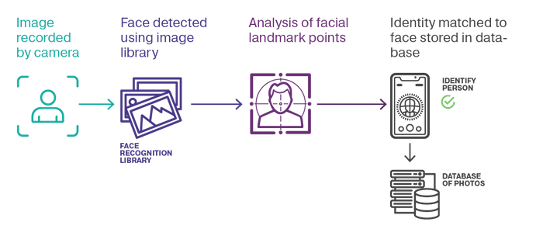***Fig. 5: Steps for Facial Recognition[17] (source: Google)***

**1.4 APPLICATIONS OF FACIAL RECOGNITION TECHNOLOGY**

**Catching Criminals:**

Many countries have implemented parts of facial recognition techniques in their departments responsible for maintaining law and order and a drastic increase in successful arrests of criminals have been executed. This was only possible due to the ability of computer to successfully recognize the face of criminals from even a crude input. Facial Recognition has many benefits and one of them is in better enforcement of law. People having a past record of crimes that would make them vulnerable to creating more terror somewhere can be tracked and stopped before they commit crimes.

**Finding missing people:**

Various countries have now started using the facial recognition app for finding missing people. In this police upload the details of people missing on the app and if someone found some people they also upload the details of that person. And then comes the work of facial recognition, it checks and compares the data of people lost and people found and see if there are any matches.

**Attendance system**

Nowadays it can be observed that many organizations like schools, colleges, offices etc. use the biometric system machines for tracking the attendance using facial recognition. It is more easy to keep a record of the people present and by adopting this method there are very low chances of giving any false attendance for anyone who is not present. Giving proxy for someone is not possible in this as every person has unique and different features. Facial Recognition can also be used for to track the attendance systems in schools and colleges this way students won’t get to bunk class unethically and would be marked absent when not actually present as this technology wouldn’t allow any other person to mark the attendance for someone who is not present

**Unlocking phones**

The face unlocking option which we have on our phones for security is only achieved by facial recognition. We are already witnessing the Facial Recognition technology in the Face Unlock features of phone which makes them more secure.

**Used in banks**

This technology can also be used to validate IDs in ATMs as many people get their debit stolen and the thief if knows the passcode may take out the money without the knowledge of the person who owns the card hence this technology would only allow people who have their face registered to the card.

**1.5 LIMITATIONS OF FACIAL RECOGNITION TECHNOLOGY**

* Low end cameras being used in security systems prove to be a limitation to the Facial Recognition Technology. The image quality being poor hampers the effectiveness of the technology.
* The input data is compared with the data of a person’s face stored and the storage and capacity require huge investments and it takes a lot of space the image samples stored of a person contain different angles and thus so many samples of every individual would require way too much space.
* The size of the image if too small again hampers the efficiency of the technology as the sample image is compared with the input image relating to its relative size and facial features and if the size of image is very small affects the systems recognition ability
* The recognition ability also depends and is influenced by the face angle of the target. The angle when not matched with angles at which the sample input was taken would affect the systems recognition ability.

**1.6 HOW TO OVERCOME THESE LIMITATIONS**

* Installing High Definition camera would be a really big help in solving the limitations because of poor image quality as then the security systems can recognise a person’s face very clearly and not hampering the effectiveness of the technology.
* Clusters of computers have to be set up with ability to store huge amounts of data with proper security in order to deal with the storage and capacity issues. This will also help in reducing the processing time by the recognition system.
* For the limitations of size or angles the solution is to install more security cameras and setup a checkpoint at which if a person crosses the security system could instantly recognise the person’s identity.
  1. **DETAILED ANALYSIS ON TYPES OF METHODS :**There are many different types of methods for facial recognition, they use the kind of algorithm that supports the purpose of that specific method; however, the different types of methods are as follows:

1. **Piecemeal/Holistic:** To get nearest to the most relevant characteristics people/researchers are following this approach. There are elements that have a relation among themselves also there are functions connected to face. There are methods that fall into this category like the Hidden Markov Model. There are also methods that use various combination of features or making the use of elements such as eyes.
2. **Geometric Based/Template Based:** Geometric Based or Template Based are two kinds of algorithm in which Facial Recognition can be divided into. The SVM, PCA, LDA Kernel Methods or Trace Transforms are the statistical tools used to build template-based methods. The Facial Features and the geometric relation that is being shared among the features is analysed by Geometric Based Methods which are also known as Feature based method.
3. **Appearance Based:** The space feature derivation from division of image is the main purpose of Appearance Based method where image is a vector with high dimensions, there are several images that are regarded with one single face. The training set gets in a comparison with the image sample just obtained. Linear and Non-Linear classifications are done for Appearance Based for example: in linear approach IDA, LDA, PCA is used while for nonlinear the approach of Kernel PCA is witnessed.

The Classification for Model Based is done in 2D and 3D model.

1. **Template Network Based:** 
   1. **Template Matching:** in this matching, samples, models, pixels, textures, etc. are the things by which the pattern is represented. The distance measure is the recognition function usually or a correlation.
   2. **Statistical Approach:** Features are how the patterns are expressed in statistical approach. D features are regarded for the representation of each image. For Extraction and analysis choosing right statistical tools becomes the goal.
   3. **Neural Networks:** The recognition of patterns and their classification is continuously being used by the Neural Network methodology. The use of this particular method to recognise or detect and then alignment or normalising of human faces was first shown by Kohonen. In this particular approach there are methods using PCA or some methods using LCA for making of a classifier which is hybrid for the purpose of Face Recognition
   4. **Local Binary Patterns Histograms (LBPH):** This calculation of this algorithm requires grayscale pictures for preparing the training. The point of LBPH is to work by squares of 3x3 pixels. The pixel in the inside is contrasted with its. Each neighbor which is smaller than the pixel in the middle, the value 0 will be added to the thresholder square which is in charge to store the results, otherwise, a 1 will be added. Each pixel has a weight to the power of two from 2x to 2y. Every pixel in the center of a 3x3 square has 8 neighbors. These eight pixels represent one byte which explains the reason of using these weights. The weights are affected in a circular order. It does not matter which weight is affected to which pixel; however, the weight of a pixel does not change. For recognizing a face, exactly the same process is performed, and the final histogram is compared to each final histogram in the training data. The label related to the closest histogram is the prediction of the algorithm. As for the hog detector, this algorithm is not sensitive to a variation of luminosity. LBPH has been modified in different ways. One of them is called Extended LBPH. This extension is using a circular shape which is composed of a radius and a number of sampling points. This approach allows a pixel to have more than eight neighbors. Another extension is called uniform pattern. This extension takes into consideration the number of transitions in the result byte. One transition is represented by a change in the byte from a 0 to a 1 or a1 to a 0. For example, 00000001 has one transition and, 00011000 has two transitions. This modification makes the vector representing the histograms smaller.

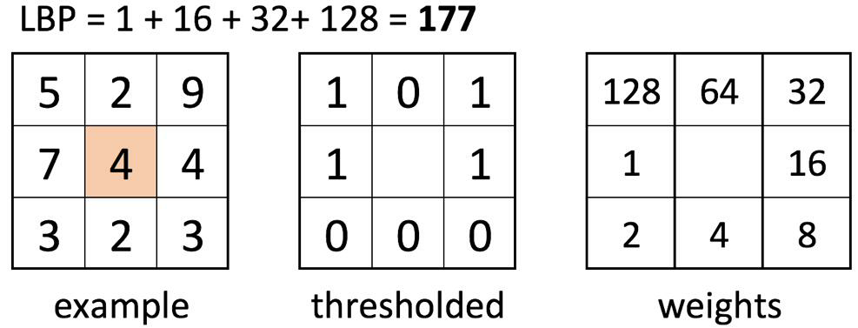 ***Figure 6. 3X3 pixel***

**1.8 LITERATURE WORK**

Priyanka and Namrata [8] in their research article techniques and implementation of face spoof recognition: perspective and prospects, talk about face spoof attacks where an illegal access can be made by using a person’s image in a photo or a video without his/her authorization. They also try to provide the idea in order to avoid such a work by any person. Their idea contains to extract four diverse features they being blurriness, chromatic moment, colour diversity and specular reflection to form the image distortion analysis or IDA feature vector.

Brijesh and Divyarajsinh in their publication Face Recognition and Applications discuss the different methods that can be used for facial recognition they being Holistic Matching Method, Feature Based Method and Hybrid Method. This publication also discusses the wide range of applications of Facial Recognition and how can these methods be applied to increase the efficiency of the technology making things more efficient and giving people more security

In their publication Face Recognition: Issues, Alternative Applications Wójcik, Gomaszek and Junisbekov talk very much in detail and probably in the most direct manner about the issues faced with this technology and its wide use of application and how can it be improved they also talk about what different methodologies can one apply in order to bring out the most successful solution. They point out the technical challenges faced also talking about how different methods can be beneficial in what different areas.

ErMengJoo and LianZhichao in their research paper Face recognition under varying illumination compare the several latest approaches while referring to them also to check the working of Facial recognition under different kinds of illumination a detailed study on LBP is done also implying different techniques. According to their paper presence of just one image for each person no satisfactory results were obtained when compared to the performance when there are more images and not just one for each person. They come to a conclusion that on combining different techniques provides a better way to deal with troubles caused by illumination.

In their publication Tenzin Dawa and N.Vijayalakshmi discuss different method or technique used for facial recognition in very much detail and try to compare the technique they discussed and tried to bring out the best of all The techniques they discussed are NMF SVM,PLS with HMM and LTP with Booth’s Algorithm.

**2. METHODOLOGY**

With the help of PyCharm we successfully executed this python based project on facial recognition. In this project the use of LBPH Face Recognition model and Haar cascaded classifier is done.

The LBPH Face recognition model stands for local binary patterns histogram. This is extensively adopted in developing facial recognition because of its easy in application nature.

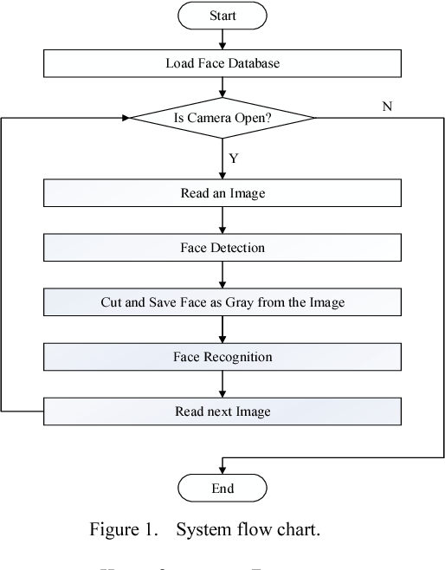

***Fig 7: Workflow of face recognition***

**2.1 The LBPH is attained by adopting the following 4 steps in recognizing the face in this project:**

1. Face detection
2. Feature extraction
3. Dataset
4. Face recognition

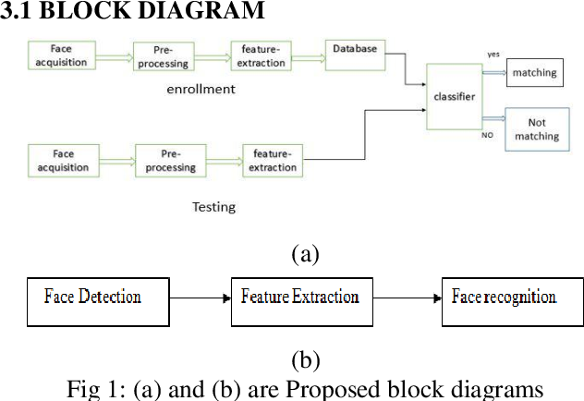

***Fig 8 : Represents the block diagram in recognition***

1. **Face Detection**

Firstly the face is detected by the computer using python based code then with the help of OpenCV(which is present in the default folder of python) the Haar cascade classifier is adopted. In the Haar cascade classifier there are various files present containing the classifications or features of various parts of the body. It firsts captures input images using the camera and then that captured input coloured image is converted into a grayscale image. After this with the help of haar cascade classifier it is observed that if there is any face in the image frame stored or not.

If no face is present then data for other images are observed otherwise if a face is present then a box is made on the face on other facial features are seen.

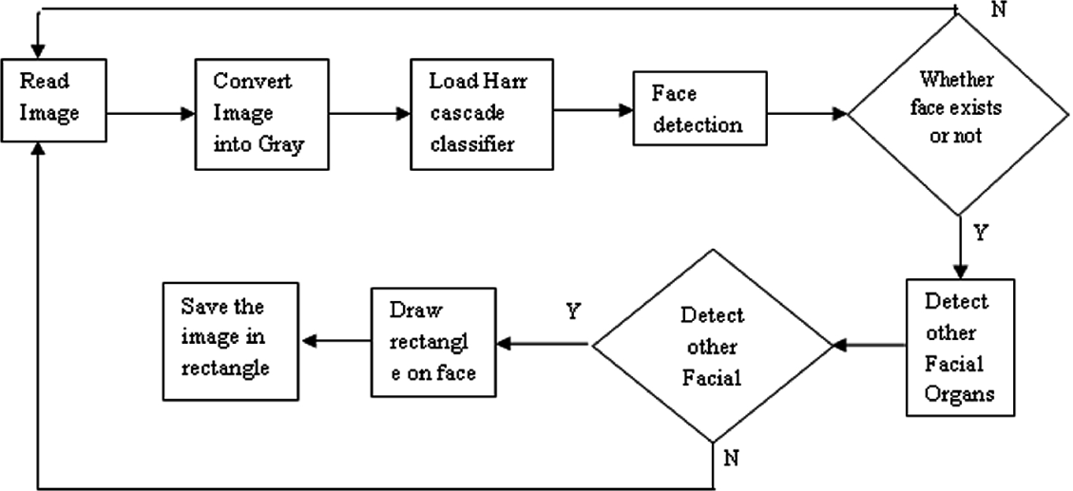

***Fig 9: Face detection block diagram***

1. **Feature Extraction**

The LBP model is used to extract the features of the face from the face. This LBP looks at the power estimation of each segment with the 8 closest neighbor pixels esteems. In the event that the estimation of the neighboring pixel is more prominent than the estimation of the focused pixel, then it sets 1 to the neighboring pixel, else it will allocate 0. An 8-bit string is provided by the task to each of its pixel. For every pixel, this undertaking gives a 8-piece string. Then the inserted image is multiplied or is split into various numbers of compact images when the LBP action and the histograms of the LBP estimation of each sub-picture are separated. At that point all histograms are connected to make a picture representing vector and it is used in training of the classifier.

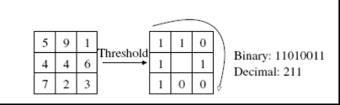

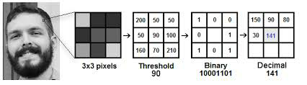

***Fig 10: The above two figures shows how the extraction of features takes place***

1. **Dataset**

In this project dataset is prepared with about 100 independent images and during the process of acquiring the images, the sample images which are detected are simultaneously edited as crop images and changed into grayscale images. Then these edited and changed photos are being placed in that folder only to build the databases of face for the extracting work.



***Fig 11: Represents the folder in which the sample images are stored***

1. **Face Recognition**

In recognizing the face we used the Local binary pattern histogram (LBPH) algorithm in which the LBP operator with the help of local binary patterns reduces the spatial distribution of the face images. It is of about 8 pixels and is a group of binary pixel value ratios in the center at regular pixel intervals.

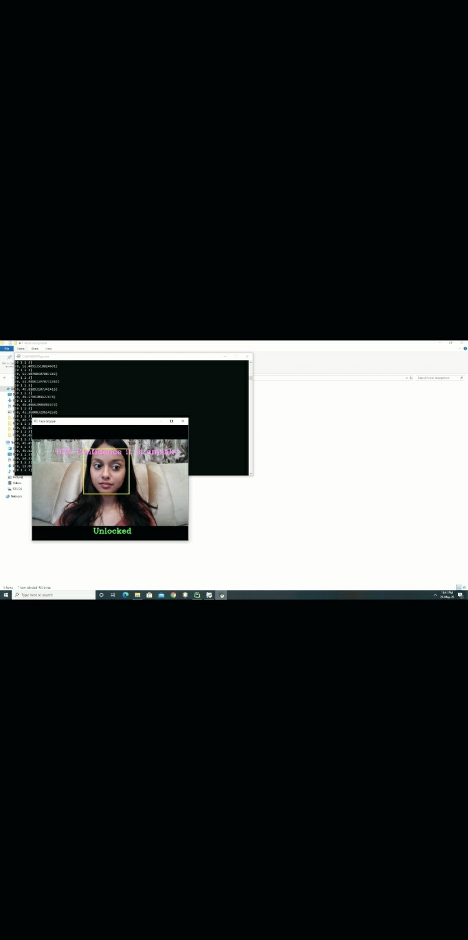

***Fig 12: The final result screen obtained after successfully recognizing the face***

**2.2 Haarcascade classifier**

In the process of face recognition there is a requirement of a group of positive images and negative image for training the classifiers. After the classifier is trained then extracting of its features is done for obtaining this we use the haar cascade features. Every attribute is a single value which is acquired by deducting the whole of pixels in white rectangle to the whole of pixels in the black rectangle.

In the Haar cascade classifier there are various files present containing the classifications or features of various parts of the body. These files are already present in the OpenCV library which is there in the python folder.



***Fig 13: Displays the various haarcascade files present in the folder***

**2.4 IMPLEMENTATION**

* First the dataset is created and necessary libraries are imported.

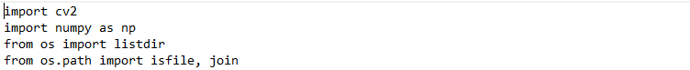

* The face detection is achieved by using the Haarcascade classifier, cropped image and converting image face into grayscale.

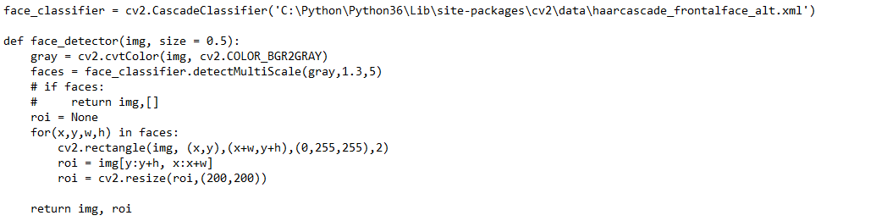

* Now using faces and label we prepare the data.

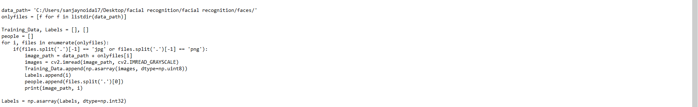

* After that we create and train the LBPH model

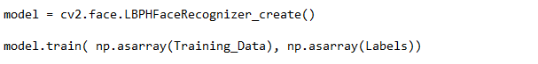

* Finally we have to test and train the model’

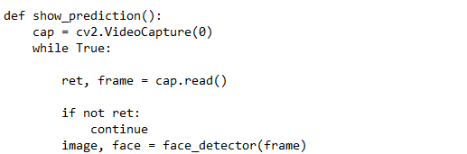

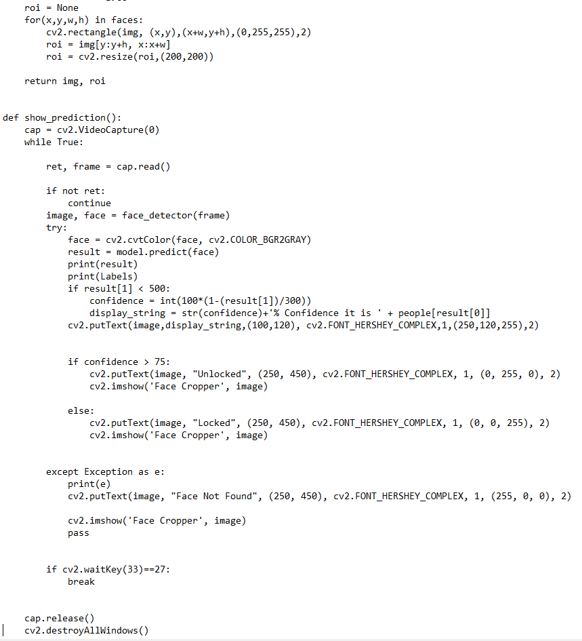

**3. RESULT**

By using the LBPH face recognition and haar cascade frontal face classifier we have successfully implemented the project in a python based software PyCharm. In this the first step involved capturing the image and converting into a cropped grayscale image. Then those grayscale images were scanned using the haarcascade frontal face classifier which detects a face. The samples images which are detected for each person are stored in the numpy array with ‘.npy’ extensions. After storing images and performing classifier extraction then comes the step of training the model. Once the training of the model is completed with the help of LBPH then the last step involves recognizing the input image with the sample images/stored images saved in the folder.

After the successful execution of the project, the following final results were observed:

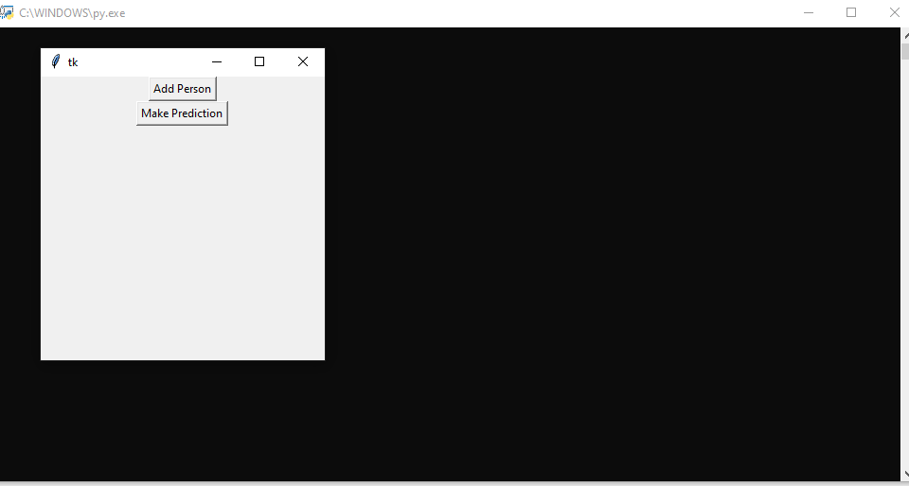

***Fig 14:Front end window***

This screen appears when we execute the code. It has two options, one to add a persons photo and the other to make the prediction. To make the prediction it is necessary to first add the persons photo so that it can recognize the image on screen with the stored sample images.



***Fig 15: Folder of saved photos***

The above screenshot represents the folder in which the sample images are stored which are added when we add the person.

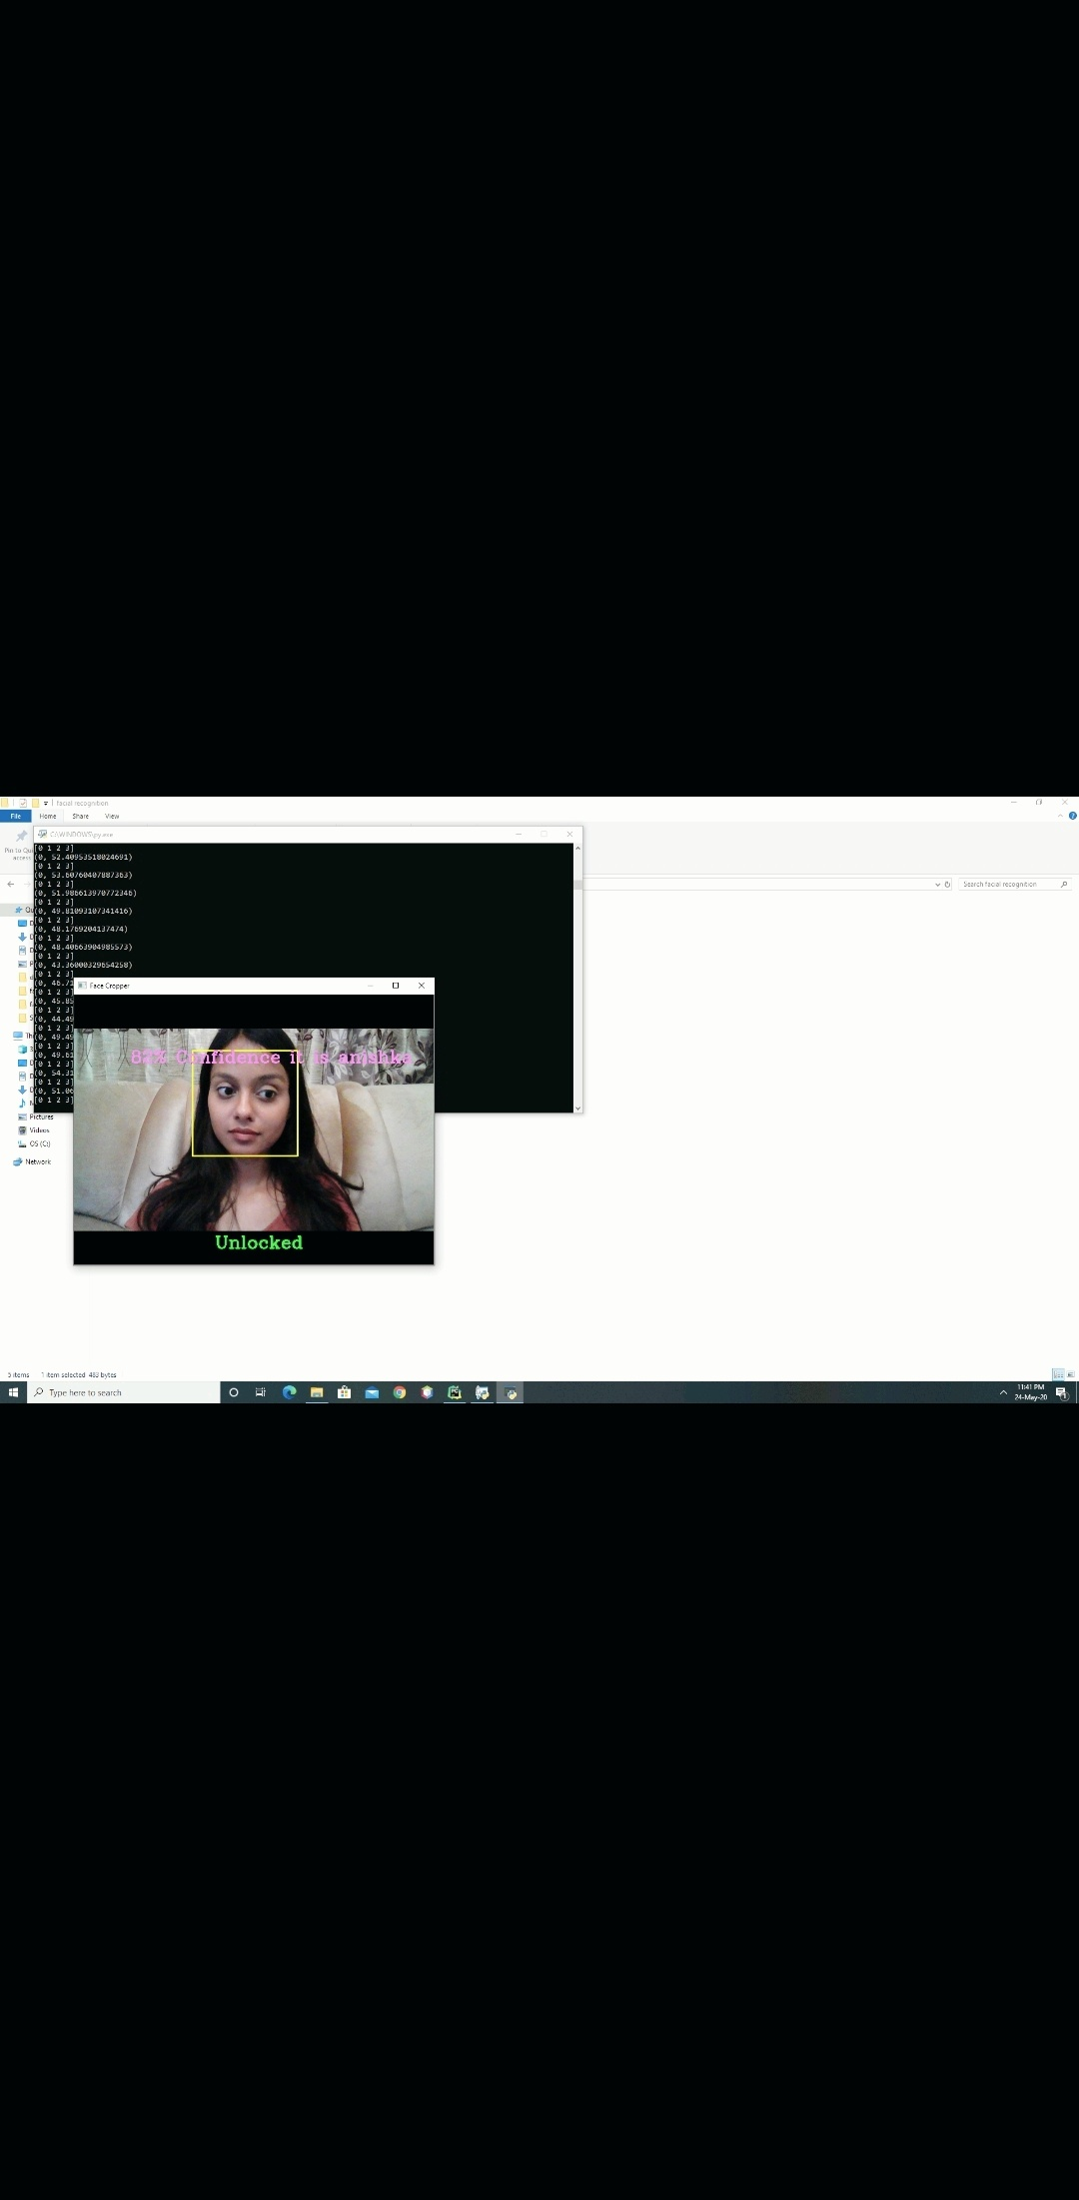

***Fig 16: Results after successful recognition***

The above figure appears when we click the make prediction option and it successfully recognizes the image on screen captured by camera with the photos saved in the face folder. In the figure we can see that the software has successfully recognized the image with the stored image and is showing that it is 82% confident that the person is ‘anishka’ and it also shows that it is hence unlocked.



***Fig 17: Performing recognition with a different user***

This screen shows the successful prediction done by the system with some different user.

The system successfully recognizes and recalls the name of the different user.

**4.CONCLUSION**

This project was implemented using python based software. With the help of LBPH algorithm and haarcascade frontal face classifier we obtained our results. Three important steps were adopted to execute the project which included detecting a face, training the model and then recognizing the face.

On the completion of our project, it is possible to detect face from images captured by the camera with an accuracy of 80-82%. The face recognition system has wide scope, it is used in many organizations like school, colleges, offices for keeping a record of the attendance.

1. **IMPLICATIONS AND FUTURE SCOPE**

This technique is widely adapted in everyday lives and will continue to be expanded in future. It is often predicted that this can most probably change the way in which we are living as our faces will be seen as passwords in many organizations like in banks, phones etc. This technique will start gripping the pace in future and will become a trending technique which is almost used everywhere. In future there main purpose is to collect various face data in databases, increasing its accuracy along with using improved versions of algorithms.